Piscataqua Watershed Curriculum
This unit is designed to engage students in grades 7-12 in citizen science in order to better understand the role of watersheds and water quality in coastal New Hampshire. This curriculum may be used as a whole or individually to meet NGSS Science Standards.
NGSS Science Standards – Disciplinary Core Ideas
LS1C: Organization for Matter and Energy Flow in Organisms
LS2A: Interdependent Relationships in Ecosystems
LS2B: Cycles of Matter and Energy Transfer in Ecosystems
LS2C: Ecosystem Dynamics, Functioning, and Resilience
ESS2C: The Role of Water in Earth’s Surface Processes
ESS3A: Natural Resources
ESS3C: Human Impacts on Earth Systems
ETS1A: Defining and Delimiting and Engineering Problem
ETS1B: Developing Possible Solutions

Objectives:
- Students will be able to describe where water is located on Earth, how water moves through the water cycle, and the availability of water for human consumption
- Students will understand the value of water and the cost of everyday use
- Students will describe the parts of a watershed and relate the Great Bay watershed to the Piscataqua River and Atlantic Ocean
- Students will understand how land use and humans effect water quality
- Students will understand what determines water quality and the history behind water quality standards
- Students will be able to use real-time data to complete bio-assessments for the Piscataqua River and the overall watershed
- Students will be able to model and design solutions to improve or maintain water quality in the local watershed
References/Sources
- http://www.noaa.gov/resource-collections/water-cycle
- http://prepestuaries.org/about-our-estuaries/maps/
- http://www.rivanna-stormwater.org/lessonplans.htm

PART 1: WATER USE AND UNDERSTANDING THE WATER CYCLE
Teacher Prep/Pre-Lesson
Humans use water for a variety of different applications including agriculture, hydropower, waste disposal, recreation, and consumption. Our close connection with water makes it imperative that we preserve and protect this resource. The water cycle is complex and not fully understood by scientists. With climate change, reducing resources, and a growing population, the water cycle plays a key role in ecosystems around the world. It is important to understand the water cycle to improve our ability to forecast climate, weather, and ecosystem health.
Climate change will affect the water cycle and water resources as droughts and extreme precipitation are expected as time goes on. A lack of clean water or an overabundance of water can affect the economy, transportation, energy use, national security, human health, and agriculture. Water is essential for life and students will be able to relate everyday activities to the water cycle.

Student Vocabulary
- accumulation: the collection of water on land.
- atmosphere: the mass of air surrounding the Earth.
- condensation: the transformation of water vapor back into liquid water by cooling.
- evaporation: the process in which the sun heats up water in rivers or lakes or the ocean and turns it into vapor; the water vapor goes into the air where it becomes a cloud.
- infiltration: the process of water passing into, or through land by filtering.
- precipitation: rain, hail, or snow falling from the clouds due to the condensation of water.
- runoff: water from rain or snow that flows over the surface of the land and into streams, rivers, lakes, ocean.
- transpiration: the process by which plants release water through the pores in their leaves.
- Water cycle: the constant movement of water from oceans and lakes, evaporating into the air as water vapor, condensing into clouds and precipitating as rain or snow onto land and back into oceans and lakes.
- Water table: location of the underground water, and the vertical distance from the surface of the Earth to this underground water.

Student Activities (see attached student worksheets)
- Label the water cycle
- The water cycle in New Hampshire
References
https://coast.noaa.gov
http://www.prism.oregonstate.edu/recent/

The Water Cycle
Name:
DIRECTIONS:
Label the water cycle diagram.
Make sure to use all the processes listed below at least once.
On the back side of this worksheet define each one.
• Evaporation
• Condensation
• Accumulation
• Transpiration
• Precipitation
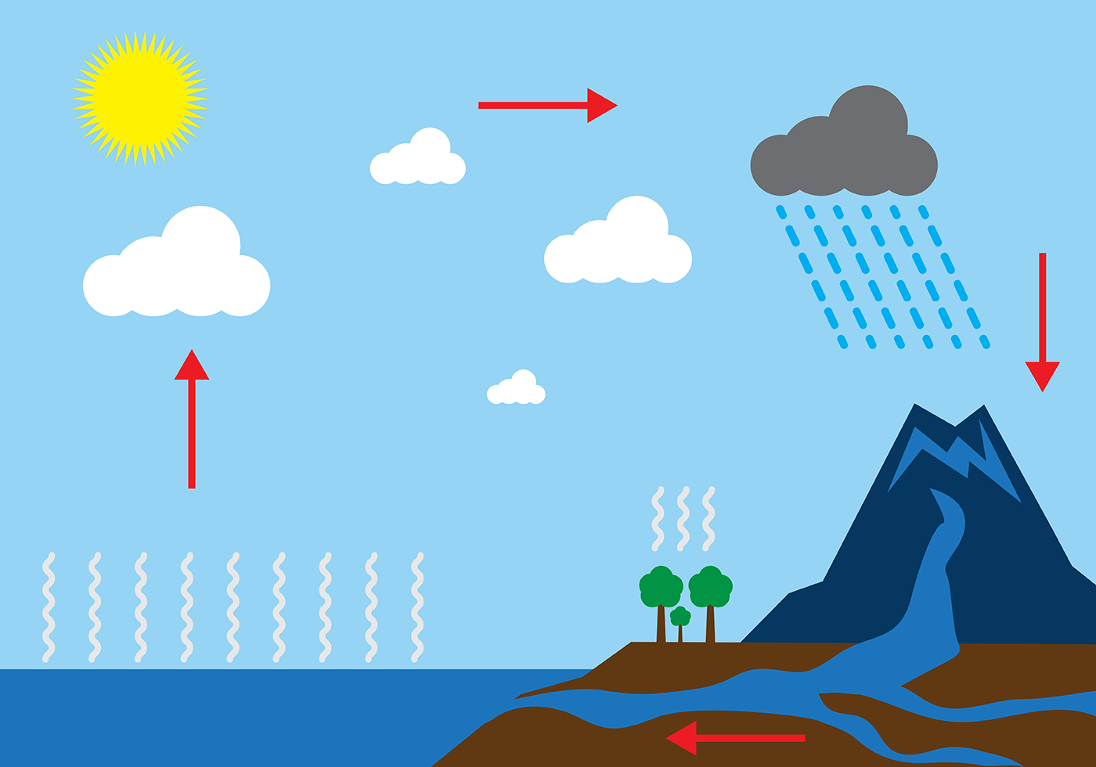
http://www.printablediagram.com/diagram-of-water-cycle/
On a separate sheet of paper, answer the following questions:
- Does the Earth have more or less water now than 1,000 years ago? Explain.
- What are two ways that water gets into the ocean?
- What are the three things necessary to form clouds?
- How do all the parts of the water cycle fit together?
- What would happen if one part of the water cycle was taken out? Give an example.

Name:
The Water Cycle in New Hampshire
Go to http://www.prism.oregonstate.edu/recent/ to download precipitation data for New Hampshire.
- When you get to the database, download daily data for the following dates:
- January 1, 2016
- March 31, 2016
- June 15, 2016
- December 25, 2016

- Using the downloaded data, graph date (x-axis) versus precipitation (y-axis).

- Answer the following questions:

- How does the amount of precipitation change in New Hampshire throughout the year?
- Why does the amount of precipitation change throughout the year?
- Find the dates with the highest and lowest precipitation. Describe what will happen to the water cycle in each of these situations.
- What time of year would have the most productive hydropower potential? Explain.

Name:
The Great Bay Watershed
Pre-Lab Questions-You will need a computer to research these questions!:
- Define the following terms on a separate sheet of paper: watershed, nonpoint source pollution, point source pollution, sediment, erosion, runoff, nutrients, impermeable surface, stream buffer
- How is the health of a watershed important to both the ecosystem and humans? List at least 3 examples for each.
- How does topography (elevation) affect runoff in a watershed?
- Give at least two examples of both point and nonpoint source pollution.
- Are sediments and nutrients a type of point or nonpoint source pollution? Explain.
- How does sediment get into a water source such as a river or lake? How can this be harmful to the organisms living there?
- Nitrogen and phosphorous are two of the most important nutrients for organism. However, the can be considered a form of pollution. Explain what happens to an ecosystem when it is polluted with these nutrients.
- What is the best way to protect a water source from nonpoint source pollution?
Materials
- Map of Great Bay Watershed (Piscataqua Region Estuary)
- Colored pencils
- Calculator
- Maps A, B, and C
Directions
Part 1:
- Go to http://prepestuaries.org/about-our-estuaries/maps/ and download the 2012 Piscataqua Region Estuary Poster and print it off
- For each sub-watershed region, trace the main river present in each region with a different colored pencil.
- Using a black colored pencil, find the Memorial Bridge in Portsmouth that crosses the Piscataqua River and make an X at its location.
Part 2: Adapted from Project WET Curriculum and Activity Guide, pp. 223-231. © www.projectwet.com and http://www.rivanna-stormwater.org/lessonplans.htm
Land use changes in a community can change a watershed in several different ways. Stormwater infiltration, water quality, erosion, and water availability can be affected by how humans use the land over time. Maps A, B, and C represent a hypothetical watershed that is changing in land use over a 100 year time period. Using the maps, complete the following activities:

ACTIVITY 2A:
- Look at Maps A, B and C. Read the key for each map. Designate each land area with a different color (e.g., color all forest areas green). They should use the same color scheme for all the maps.
- Answer the following questions on a separate sheet of paper:
  - What happens to the amount of forested land as you go from Map A to Map C?

  - Which map has them most land devoted to human settlement?

  - Where are most of the human settlements located?

  - What effect might these human settlements have on the watershed?

  - Would you have handled development differently?

ACTIVITY 2B:
- Determine the land area of each of the maps. Each unit on the grid represents one square kilometer. There are 360 square kilometers (or 360,000,000 square meters) on each map.

- For each map, determine how much area is occupied by each type of land coverage (e.g., forest, wetland, and farmland). Responses can be guesses or exact calculations. For example, for Map A, 17 of the grid units are occupied by wetlands. By dividing 17 by the total number of units (360), students can calculate that 4.7% of the land area is wetlands. Record your answers in the cahrt below.
 |  | Map A |  |  | Map B |  |  | Map C
 | 100 yrs ago |  |  | 50 yrs ago |  |  |  | Present
Land | km² |  | % | km² |  | % | km² |  | %
Coverage
Forest
Grassland
Wetland
Residential
Agriculture
Stream

3.The watershed in Map C has received 5 cm (0.05 m) of rain. (Although rain does not normally fall evenly on a large area, assume that the 5 cm of rain fell evenly over the entire watershed.) Convert both the rainfall and the land area to meters. Calculate the amount of water (m³) which fell on the land.

Amount of Water fallen:____________________________
- How does this compare to the average rainfall for New Hampshire found in the Water Cycle in New Hampshire activity?

4.Estimate the amount of water that would be drained from the land into the river. The watershed represented by Map A, 2,767,500 m² of rain was runoff (i.e., the water flowed into the river and did not soak into the ground, did not evaporate and was not used by plants or animals).

Estimated amount of water drained from land to river:____________________________________

- Look at the land coverage in Map A and Map C. Do you think that the runoff would increase or decrease? Explain your answer.

5.When 12,450,000 m³ of rain fell on the land represented by Map A, 1,922,500 m³ was runoff. For Map B 2,871,500 m³ was runoff. Discuss the following questions:

  - Which absorbs more water, concrete or forest (or wetlands, or grasslands)?

  - Which map represents the watershed that is able to capture and store the most water?

  - What problems could arise if water runs quickly over surface material, rather than moving slowly or soaking in?

  - How might the water quality of the river be affected by changes in the watershed?

ACTIVITY 3B:

- Determine how the figures in ACTIVITY 2B were obtained. In the chart Volume of Rain and Volume of Runoff, each land area has been assigned a proportion of the water that is not absorbed or that runs off its surface. Using the information from this chart and from the Area of Land Coverage chart, calculate the amount of water that each land area does not absorb. For example, for the forested land in Map A, 189 km² x 1,000,000 m²/km² = 189,000,000 m² of land. Multiply this by the amount of rainfall (189,000,000 m² x 0.05 m = 9,450,000 m³). Since 10% of the rainfall was runoff, 945,000 m³ of water drained into the river from the forested land (9,450,000 m³ x .20). Complete the Volume of Rain and Volume of Runoff chart below.

Note: The figures for percent runoff are based on hypothetical data. To determine how much water is absorbed by surface material, one needs to know the soil type, texture, slope, vegetation, intensity of rainfall, etc. In addition, many farms and urban areas practice water conservation measures that help retain water and prevent it from flowing over the surface of the land. The information in the chart is intended only for practice and comparisons.

Volume of Rain and Volume of Runoff

Map A | Map B | Map C
100 years ago | 50 years ago | Present

Land Cover

and % Runoff

Forest

10% Runoff

Grassland

20% Runoff

Wetland

5% Runoff

Residential

90% Runoff

Agriculture

30% Runoff

Total Runoff

Total Runoff +

Stream
Discharge

(5,550,000 m³)

Wrap Up and Action

- Summarize how changes in land us e affect the quantity and quality of runoff in a watershed. Discuss land use practices in the community and how they may affect water discharge in the watershed. Take a walking tour around the school and note areas that contribute to or reduce stormwater runoff. (for example, roof, parking lots, paved roads and sidewalks promote runoff; parks, wetlands, and trees capture water.)

- Have students draw maps of how they think the community will look in 100 years. Alternatively, have them draw two maps, of the best-case scenario and the worst-case scenario regarding development that will decrease or increase runoff.

- Have students research ways that development can proceed without increasing runoff. Discuss Low Impact Development techniques that can reduce runoff (see suggested links below).

Part 3: (Using the Part 2 Maps and graphs as a reference, you will analyze the Great Bay Watershed map from Part 1)
- Choose one of the sub-watersheds from the Piscataqua Map and fill out the Great Bay Watershed Data table using the internet and the map.
- Come together as a class and share data so that everyone in the class has a complete data table.

GREAT BAY WATERSHED DATA
Sub-Watershed | Approximate Size | Length of Major River Source | Approximate Population | Point Sources of Pollution | Non-Point Sources of Pollution | % Forest | % Wetland | % Residential | % Grassland | % Agriculture | % River

Map A: 100 Years Ago
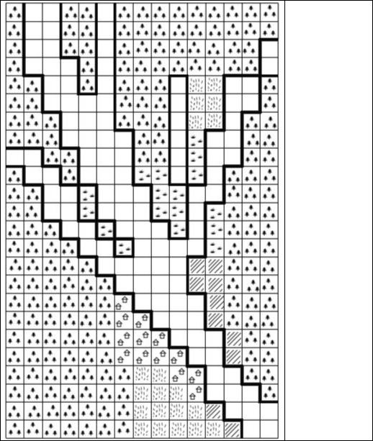

KEY

Forest
Wetland Grassland Residential Agricultural
River

Map B: 50 Years Ago
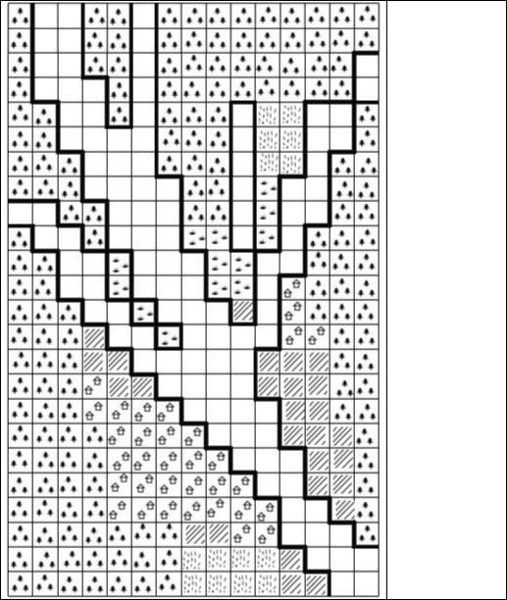

KEY
Forest Wetland Grassland Residential Agricultural River

Map C: Present
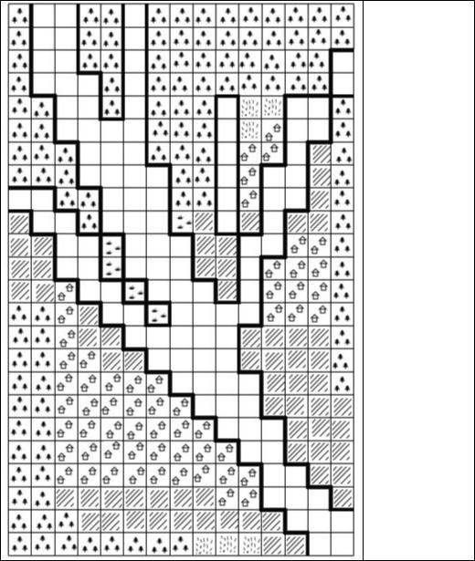

KEY

Forest Wetland Grassland Residential Agricultural River

